A FEDERATED LEARNING–INSPIRED WEB APPLICATION FOR PRIVACY-PRESERVING PROSTATE CANCER RISK PREDICTION
Submitted in partial fulfilment of requirements to CSE (Data Science)

Project -I (CD – 363)
III/IV B. Tech CSE (DS) (VI Semester)
Submitted by
Ponnaluri Jeyanth (Y23CD148) Pudota Jaideep (Y23CD149)



MARCH 2026
R.V.R. & J.C. COLLEGE OF ENGINEERING

(Autonomous)
(NAAC A+ Grade) (Approved by A.I.C.T.E.) (Affiliated to Acharya Nagarjuna University) Chandramoulipuram : : Chowdavaram Guntur – 522 019

R. V. R. & J. C. COLLEGE OF ENGINEERING

DEPARTMENT OF
COMPUTER SCIENCE AND ENGINEERING (DATA SCIENCE)



CERTIFICATE
This is to certify that this project report “A FEDERATED LEARNING–INSPIRED WEB APPLICATION FOR PRIVACY-PRESERVING PROSTATE CANCER
RISK PREDICTION “is the Bonafide work of “Ponnaluri Jeyanth (Y23CD148), Pudota Jaideep (Y23CD149)” who has carried out the work under my supervision and submitted in partial fulfilment for the award of Project - I (CD-363) during the year 2025- 2026.

Dr. Rajesh Yamparala  Project Incharge | Dr. M.V.P.Chandra Sekhara Rao  Prof. & HOD, CSDS  And  Project Guide

ACKNOWLEDGEMENT

I would like to express my sincere gratitude to these dignitaries, who are with us in the journey of my Summer Internship “A FEDERATED LEARNING–INSPIRED WEB APPLICATION FOR PRIVACY-PRESERVING PROSTATE CANCER RISK PREDICTION.”
First and foremost, I extend my heartfelt thanks to Dr. Kolla Srinivas, principal of R. V.
R. & J. C. College of Engineering, Guntur, for providing me with such overwhelming environment to undertake this internship.
I am utmost grateful to Dr. M. V. P. Chandra Shekar Rao, Head of the Department of Computer Science and Engineering (Data Science) for paving a path for me and assisting me to meet the requirements that are needed to complete this internship.
I extend my gratitude to the Project in-charge Dr.Rajesh Yamparala for his ecstatic guidance and feedback throughout the project. His constant support and constructive criticism have helped me in completing the internship.
I would like to express my sincere gratitude to my Project Guide, Dr. M. V. P. Chandra Sekhara Rao, for his invaluable guidance and feedback throughout this project.
I would also like to express my sincere thanks to my friends and family for their moral support though out our journey.

Ponnaluri Jeyanth (Y23CD148) Pudota Jaideep (Y23CD149)

ABSTRACT
Healthcare institutions generate large volumes of sensitive patient data that are valuable for building predictive models to assist in early disease detection and clinical decision support. However, privacy regulations such as the Health Insurance Portability and Accountability Act (HIPAA) and institutional data governance policies restrict the sharing of raw medical data across hospitals and research institutions. This imposes a significant barrier to collaborative research and the development of generalizable machine learning models in the medical domain.

Federated Learning (FL) provides an innovative solution by enabling collaborative model training without requiring the exchange of patient data between institutions. In federated learning, each participating institution trains a local machine learning model on its own dataset and only shares model parameters, such as weights and gradients, with a central aggregation server. The server combines these parameters to produce an improved global model, which is then redistributed to all participants for the next training round.

This project presents a comprehensive Federated Learning research framework designed for prostate cancer stage classification using clinical datasets obtained from The Cancer Genome Atlas Prostate Adenocarcinoma (TCGA-PRAD) database. The system predicts whether prostate cancer is in an early stage (T1/T2) or an advanced stage (T3/T4) based on key patient clinical attributes including Gleason score, PSA levels, age at diagnosis, and pathological staging information. A logistic regression model serves as the primary classification algorithm due to its interpretability and efficiency in binary classification tasks.

The framework implements multiple experimental versions to comprehensively evaluate federated learning in healthcare settings. Version-1 establishes a centralized baseline using traditional logistic regression on the complete aggregated dataset. Version-2 introduces distributed training using the Federated Averaging (FedAvg) algorithm, simulating multiple hospital environments. Version-3 evaluates the scalability of the framework as the number of participating institutions grows, and investigates free-rider behavior where a hospital contributes no useful data but benefits

from the global model. Version-4 studies model stability under heterogeneous non-IID (non-Independently and Identically Distributed) data conditions using the FedProx regularization algorithm. Version-5 introduces hospital contribution analysis using a leave-one-out methodology to quantify the impact of each participating institution on the overall model performance.

The complete system is deployed as a Streamlit-based interactive web application, enabling simulation of multiple hospital environments, real-time visualization of learning curves, model performance dashboards, and patient-level risk prediction. Experimental results demonstrate that federated learning can achieve performance comparable to centralized training while maintaining strict data privacy guarantees.

The proposed framework provides a versatile and extensible platform for experimenting with privacy-preserving machine learning methods in healthcare environments, and contributes to the growing body of research on federated learning applications in clinical informatics.

CHAPTER 1 – INTRODUCTION

  - Introduction of the Project
Healthcare organizations produce vast amounts of clinical and genomic data that can be leveraged to develop predictive models for disease detection, prognosis, and personalized treatment planning. In the field of oncology and cancer research, machine learning techniques have been extensively applied to analyze patient records, imaging data, and molecular profiles to predict disease progression, treatment response, and survival outcomes.
Prostate cancer is among the most prevalent malignancies in males worldwide, and accurate staging of the disease at diagnosis is critical for treatment planning. Early-stage prostate cancer (T1/T2) is typically managed with active surveillance or localized treatment, while advanced-stage cancer (T3/T4) may require more aggressive interventions including radiation therapy, hormone therapy, or surgery. Machine learning models trained on clinical data can assist clinicians in making accurate staging decisions and can contribute to more personalized and effective treatment pathways.
However, developing robust machine learning models for prostate cancer staging requires access to large, diverse clinical datasets. Sharing medical data between hospitals is extremely difficult due to privacy regulations such as the Health Insurance Portability and Accountability Act (HIPAA) in the United States, the General Data Protection Regulation (GDPR) in Europe, and various national healthcare data governance policies. These regulations prohibit institutions from sharing identifiable patient data without explicit consent, creating a major barrier to collaborative research.
Federated Learning (FL) is a distributed machine learning paradigm introduced by McMahan et al. at Google in 2017. It enables multiple institutions to collaboratively train machine learning models without sharing raw data. Instead of transferring patient data to a central server, each institution trains a local model on its own dataset and only shares the model parameters, such as weight vectors or gradients, with a central aggregation server. The server combines these parameters to produce a global model, which is then redistributed to all participants for the next training round.
This project proposes a comprehensive Federated Learning framework for prostate cancer stage classification using clinical data from the TCGA-PRAD dataset. The system predicts whether

prostate cancer is in an early stage or an advanced stage based on patient clinical attributes. A modular research framework was developed to simulate multi-hospital training scenarios, evaluate model performance under heterogeneous data conditions, investigate free-rider behavior and system scalability, and analyze the contribution of individual participating institutions to the collaborative learning process.
The system is deployed as an interactive Streamlit web application that allows medical researchers, data scientists, and clinicians to configure federated learning experiments, visualize model convergence, and generate patient-level risk predictions without requiring programming expertise.

  - Existing System
Traditional machine learning systems in healthcare rely on centralized data collection and processing. In such systems, patient data from multiple hospitals and research institutions are collected, transferred, and stored in a centralized database before training predictive models. The centralized approach offers several advantages: it simplifies model training by making all data available in one place, allows the use of large datasets, and facilitates straightforward model evaluation.
Centralized systems have been used effectively in well-controlled research environments, such as The Cancer Genome Atlas (TCGA), where patients provide explicit consent for data sharing. However, in real-world clinical deployments, centralized approaches present several significant limitations that prevent their practical adoption at scale.

Limitations of Existing Centralized Systems
Privacy Concerns: Medical records contain highly sensitive patient information including diagnoses, genetic data, and treatment history. Transferring this data to external servers violates patient privacy and creates legal and ethical risks.
Regulatory Restrictions: Healthcare institutions are legally prohibited from sharing identifiable patient data without explicit consent under HIPAA, GDPR, and other regulations.
Data Ownership Issues: Hospitals and research institutions often do not want to relinquish control of proprietary datasets that have significant commercial or scientific value.
Security Risks: Centralized databases aggregating large volumes of sensitive medical data become high-value targets for cyberattacks and data breaches.

Scalability Challenges: Processing and storing large centralized medical datasets requires significant infrastructure and computational resources.
Data Silos: Smaller hospitals with limited data may be excluded from collaborative research due to data transfer barriers.
Due to these limitations, centralized machine learning approaches are often impractical in real-world healthcare collaborations. This motivates the need for privacy-preserving distributed machine learning approaches such as federated learning.
  - Proposed System
The proposed system introduces a comprehensive Federated Learning framework that allows multiple hospitals to collaboratively train a prostate cancer stage classification model without sharing patient data. The framework preserves data privacy while enabling collaborative model improvement across institutions.
In the proposed system, each hospital retains its local dataset on its own servers and trains a local logistic regression model using its available clinical data. The locally trained model parameters (coefficient vectors and intercepts) are then transmitted to a central aggregation server. The server applies the Federated Averaging algorithm to aggregate the received parameters into a global model. The updated global model is then redistributed to all participating hospitals, and this process repeats for multiple training rounds until convergence.
The proposed framework includes five experimental components designed to comprehensively evaluate federated learning performance in healthcare settings:

Version | Component | Key Functionality
Version 1 | Centralized Baseline | Traditional logistic regression on pooled data
Version 2 | FedAvg Training | Federated Averaging across simulated hospitals

Version | Component | Key Functionality
Version 3 | Scalability & Free-Rider Analysis | Evaluates behavior as hospitals scale
Version 4 | FedProx Heterogeneity Study | Handles non-IID data distributions
Version 5 | Hospital Contribution Analysis | Leave-one-out importance measurement

The system is implemented as a Streamlit web application, allowing users to simulate federated learning experiments, configure parameters interactively, and visualize results through dashboards and charts.

  - Potential Users
The proposed federated learning framework is designed to serve a diverse set of stakeholders in the healthcare and research domains:
    - Healthcare Researchers: Scientists studying collaborative machine learning for clinical prediction tasks who need privacy-preserving alternatives to data sharing.
    - Hospitals and Medical Centers: Healthcare institutions interested in participating in
federated research collaborations without transferring patient data outside their network.
    - Medical Data Scientists: Professionals developing predictive healthcare models who require tools for distributed model training and evaluation.
    - Academic Researchers: Graduate students and faculty studying federated learning systems, privacy-preserving AI, and distributed machine learning in real-world healthcare contexts.
    - Healthcare Organizations and Policy Makers: Organizations exploring distributed AI
solutions that comply with data privacy regulations while enabling collaborative research.

    - Clinical Informaticists: Professionals designing health informatics systems that incorporate machine learning while maintaining patient confidentiality.

  - Unique Features of the System
The proposed system provides several unique features that distinguish it from existing healthcare machine learning platforms:
    - Privacy-Preserving Collaborative Learning: Hospitals collaboratively train models without sharing any patient-level data, maintaining strict data privacy throughout the learning process.
    - Modular Federated Learning Experimentation Framework: The five-version modular design allows independent evaluation of centralized baselines, federated training,
scalability, heterogeneity, and contribution analysis.
    - Simulation of Multi-Hospital Training Environments: The framework realistically simulates federated learning across multiple institutions with configurable data
distributions and participation rates.
    - Visualization of Model Convergence and Performance: Interactive dashboards display
learning curves, ROC curves, confusion matrices, and per-hospital performance metrics across training rounds.
    - Analysis of System Scalability and Fairness: The framework evaluates how model
performance changes as more hospitals join the federation and detects free-rider behavior.
    - Hospital Contribution Measurement: Leave-one-out analysis quantifies each hospital's contribution to the global model, enabling fair incentive mechanisms.
    - Streamlit Web Interface: A user-friendly web application enables non-programmers to configure and run experiments without writing code.

  - Demand for the Product
The demand for privacy-preserving AI solutions in healthcare is growing rapidly as institutions seek to harness the power of machine learning while complying with increasingly stringent data privacy regulations. The global federated learning market in healthcare is projected to grow significantly over the next decade, driven by several key trends.

First, stricter data privacy regulations such as HIPAA in the United States, GDPR in Europe, and the Digital Personal Data Protection Act in India are making it increasingly difficult for hospitals to share patient data for research purposes. Federated learning provides a compliant alternative that enables collaborative research without data transfer.
Second, the increasing availability of clinical data at individual hospitals creates the opportunity for distributed collaborative research. Federated learning allows smaller hospitals with limited data to participate in large-scale research collaborations and benefit from models trained on diverse datasets.
Third, advancements in federated learning algorithms, secure aggregation protocols, and differential privacy techniques are making federated learning increasingly practical and reliable for real-world healthcare deployments. The proposed framework contributes to this ecosystem by providing a research-grade platform for evaluating federated learning in clinical settings.

  - Protection of Idea
The proposed system is based on open research concepts in federated learning, machine learning, and clinical data analysis. Intellectual property protection can be ensured through the following mechanisms:
    - Academic Publication: Publishing research findings on the proposed framework's
performance, novel algorithms, and experimental results in peer-reviewed conferences and journals.
    - Documentation of Algorithmic Contributions: Maintaining detailed technical
documentation of any novel algorithmic contributions, including the hospital contribution measurement methodology and free-rider detection mechanisms.
    - Open-Source Software Licensing: Releasing the framework under an open-source license such as Apache 2.0 or MIT, which provides attribution requirements while encouraging community adoption.
    - Institutional Collaboration Agreements: Formalizing collaboration agreements with partner institutions to establish data usage policies, intellectual property rights, and publication authorship.

CHAPTER 2 – LITERATURE SURVEY & SRS

  - Literature Review
Federated Learning was formally introduced by McMahan et al. (2017) in their seminal work 'Communication-Efficient Learning of Deep Networks from Decentralized Data.' The paper introduced the Federated Averaging (FedAvg) algorithm, which remains the most widely used federated learning aggregation method. FedAvg enables multiple clients to train local models and aggregate parameters at a central server, significantly reducing communication overhead compared to stochastic gradient descent-based approaches.
Since its introduction, federated learning has been extensively studied in various application domains including natural language processing, computer vision, and healthcare. In the healthcare domain, federated learning has emerged as a promising solution for enabling collaborative research across institutions while maintaining compliance with data privacy regulations.
Rieke et al. (2020) conducted a comprehensive survey of federated learning applications in medical imaging, demonstrating that federated models trained across multiple institutions can achieve performance comparable to centralized models trained on pooled data. Their work highlighted the importance of handling data heterogeneity across institutions with different patient populations and imaging protocols.
Li et al. (2020) introduced the FedProx algorithm as an extension of FedAvg designed to improve convergence under heterogeneous non-IID data conditions. FedProx adds a proximal regularization term to the local objective function that penalizes deviation of local model parameters from the global model. This stabilizes training when participating clients have different data distributions, which is common in real-world multi-institutional healthcare collaborations.
Sheller et al. (2020) applied federated learning to brain tumor segmentation across multiple medical institutions and demonstrated that federated learning approaches can match the performance of centralized training while maintaining strict data privacy. Their work showed that federated learning is particularly effective when data is scarce at individual institutions but diverse across the federation.
In the context of prostate cancer research, several studies have applied machine learning to clinical staging and prognosis prediction using TCGA-PRAD data. However, the application of federated

learning specifically to prostate cancer stage classification across simulated multi-hospital environments represents a relatively unexplored area that this project addresses.

    - Review Findings
The comprehensive literature review reveals several key findings that informed the design and implementation of the proposed federated learning framework:
      - Performance Parity: Multiple studies confirm that federated learning can achieve
performance comparable to centralized training across various healthcare prediction tasks, validating the feasibility of the proposed approach.
      - Data Heterogeneity Challenges: Data heterogeneity across institutions is one of the
primary technical challenges in federated learning. Non-IID data distributions can slow convergence and reduce model performance, motivating the inclusion of FedProx in Version-4.
      - Communication Efficiency: Communication overhead between clients and the server is a key bottleneck in federated learning systems. FedAvg addresses this by performing
multiple local training epochs before each communication round.
      - Incentive Mechanisms: Free-rider behavior, where institutions benefit from the global model without contributing meaningful local data or computation, is a recognized
challenge in federated learning systems that requires detection and mitigation.
      - Contribution Analysis: Fair assessment of individual institution contributions is important for designing incentive mechanisms and ensuring equitable participation in federated
learning federations.
      - Security and Privacy: While federated learning prevents raw data sharing, additional protections such as differential privacy and secure aggregation are needed to prevent inference attacks on shared model parameters.

    - Objectives of the System
Based on the literature review and project requirements, the following objectives were defined for the proposed federated learning framework:

- Develop a modular federated learning framework for clinical prediction tasks using the TCGA-PRAD prostate cancer dataset.
- Compare the performance of centralized training (Version-1) and federated training (Version-2) using standard evaluation metrics including accuracy, F1-score, and AUC-ROC.
- Evaluate the scalability of the federated learning framework as the number of
participating hospitals increases, and investigate the impact of free-rider institutions (Version-3).
- Analyze the stability and convergence of the federated model under heterogeneous non-IID data distributions using the FedProx algorithm (Version-4).
- Measure the contribution of individual hospitals to the collaborative federated learning process using leave-one-out analysis (Version-5).
- Deploy the complete framework as a user-friendly Streamlit web application to enable interactive experimentation and visualization.

  - Requirements Analysis

    - Functional Requirements
The functional requirements describe the specific behaviors and capabilities that the federated learning system must provide to its users:

Functional Requirement | Description
Dataset Upload | Users can upload clinical datasets in CSV format for processing and model training.
Data Preprocessing | The system preprocesses patient records including handling missing values, feature scaling, and train-test splitting.

Functional Requirement | Description
Centralized Model Training | Version-1 trains a logistic regression model on the complete pooled dataset as a baseline.
Federated Model Training | Version-2 simulates federated training across configurable numbers of hospitals using FedAvg.
Free-Rider Simulation | Version-3 introduces hospitals with no useful data to evaluate federation robustness.
FedProx Training | Version-4 applies proximal regularization for heterogeneous data handling.
Contribution Analysis | Version-5 measures each hospital's contribution using leave-one-out methodology.
Performance Visualization | The system generates ROC curves, confusion matrices, and learning curves.
Patient Risk Prediction | Users can input patient clinical attributes to generate cancer stage predictions.
Experiment Configuration | Users can configure the number of hospitals, training rounds, and other hyperparameters.

    - User Requirements
The user requirements define what end users need to accomplish with the system in practical scenarios:
      - Medical researchers must be able to upload their clinical datasets and configure federated learning experiments without requiring programming expertise.

      - Data scientists must be able to access detailed performance metrics and visualizations to analyze model convergence and compare experimental configurations.
      - Hospital administrators must be able to simulate federated learning scenarios with configurable numbers of participating institutions and data distribution settings.
      - Academic researchers must be able to reproduce experiments and export results for publication and further analysis.
      - Clinicians must be able to use the prediction interface to generate patient-level risk assessments based on clinical input data.
    - Non-Functional Requirements

Requirement | Specification
Data Privacy | Raw patient data must never be shared between  simulated hospital nodes during federated training.
Performance | The system must complete training experiments within reasonable time on standard hardware configurations.
Scalability | The framework must support simulation of up to 20 or more hospital nodes without performance  degradation.
Reproducibility | All experiments must be reproducible using fixed random seeds and documented configurations.
Usability | The Streamlit web interface must be intuitive and usable by non-programmers in the healthcare domain.

Requirement | Specification
Reliability | The system must handle missing data, class  imbalance, and heterogeneous data distributions gracefully.
Extensibility | The modular architecture must allow future integration of additional federated learning algorithms and datasets.
Documentation | Complete technical documentation must be provided for all modules, algorithms, and experimental configurations.

    - System Requirements
The following hardware and software requirements are necessary for deploying and running the federated learning framework:

Category | Component | Specification
Hardware | RAM | Minimum 8 GB (16 GB recommended)
Hardware | Processor | Multi-core CPU (Intel i5/i7 or AMD Ryzen 5/7)
Hardware | Storage | At least 10 GB free disk space
Hardware | Network | Stable internet connection for Streamlit deployment

Category | Component | Specification
Software | Operating System | Windows 10/11, macOS 12+, or Ubuntu 20.04+
Software | Python | Python 3.8 or higher
Software | Streamlit | Version 1.22 or higher
Software | Scikit-learn | Version 1.0 or higher
Software | NumPy | Version 1.21 or higher
Software | Pandas | Version 1.3 or higher
Software | Matplotlib | Version 3.4 or higher
Software | Plotly | Version 5.0 or higher

  - Modules Description
The federated learning system is organized into the following major modules, each responsible for a distinct set of functionalities:

Module | Description
Data Preprocessing Module | Handles dataset loading, missing value imputation, feature selection, normalization, and stratified train-test splitting. Supports both pooled (centralized) and partitioned (federated) data preparation.

Module | Description
Centralized Model Training Module | Implements logistic regression training on the  complete pooled dataset to establish a performance baseline for comparison with federated approaches.
Federated Learning Engine | Core engine implementing FedAvg and FedProx algorithms. Manages local training rounds,  parameter aggregation, global model updates, and convergence monitoring.
Hospital Simulation Module | Simulates multiple hospital environments by  partitioning the dataset across configurable numbers of nodes with varying data distribution patterns including IID and non-IID settings.
Experiment Analysis Module | Implements leave-one-out contribution analysis, free-rider detection, scalability evaluation, and statistical comparison of experimental  configurations.
Visualization Module | Generates interactive charts including ROC curves, confusion matrices, learning curves, contribution bar charts, and federation topology diagrams using  Plotly and Matplotlib.
Prediction Interface Module | Provides an interactive form for clinical attribute input and generates patient-level cancer stage  predictions with probability scores.

CHAPTER 3 – SYSTEM DESIGN

  - Design Concepts and Constraints
The system design follows a modular architecture that clearly separates the concerns of data processing, model training, federated aggregation, and visualization. The design prioritizes flexibility and extensibility to support future research experiments with different datasets, algorithms, and evaluation methodologies.
The overall architecture is inspired by the classical federated learning paradigm, where a central coordinator orchestrates the training process across multiple distributed client nodes. In the proposed simulation framework, both the coordinator and the client nodes are implemented as software components running on a single machine, with data partitioned to simulate the distributed environment.
Several key design constraints were identified and addressed during the system design phase:
    - Privacy Constraint: The system must ensure that no raw patient data is transmitted between simulated hospital nodes. Only model parameters are shared.
    - Modularity Constraint: Each experimental version (V1 through V5) must be
independently runnable and configurable without modifying shared components.
    - Reproducibility Constraint: All experiments must produce consistent results across runs using fixed random seeds.
    - Usability Constraint: The web interface must be accessible to healthcare researchers without programming backgrounds.
    - Scalability Constraint: The architecture must support experimentation with varying numbers of hospital nodes without fundamental redesign.

  - System Architecture Overview
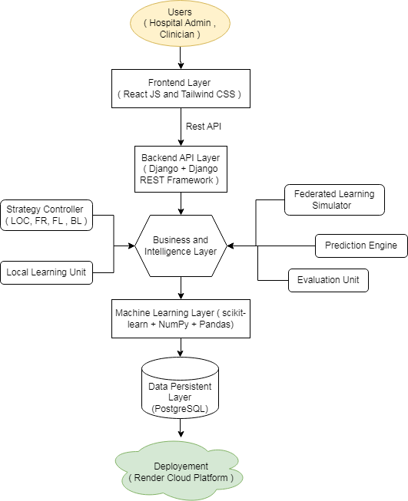

Fig 3.1: System Architecture
The proposed system follows a three-tier architecture comprising a data layer, a processing layer, and a presentation layer. The data layer handles clinical dataset storage and partitioning. The processing layer implements the federated learning algorithms, local training, and aggregation logic. The presentation layer provides the Streamlit web interface for user interaction and result visualization.
The federated learning workflow follows a cyclical process:
- The central server initializes a global logistic regression model with random parameters.
- The global model is distributed to all participating hospital nodes.
- Each hospital node trains the model locally on its private dataset for a configured number of epochs.

- Each hospital transmits the locally trained model parameters to the central server.
- The central server aggregates the received parameters using FedAvg (weighted average by dataset size).
- The updated global model is redistributed to all hospitals and the cycle repeats.
- After all training rounds complete, the final global model is evaluated on a held-out test set.

Key Architectural Components
Central Aggregation Server: Orchestrates the federated training process, receives local model parameters, performs weighted averaging, and distributes the updated global model.
Hospital Client Nodes: Simulate individual medical institutions, each with a private data partition. Each node performs local model training and transmits parameters.
Data Partitioner: Divides the TCGA-PRAD dataset into hospital-specific partitions following IID or non-IID distributions.
Experiment Controller: Manages experimental configurations, executes training workflows for all five versions, and coordinates result collection.
Evaluation Engine: Computes performance metrics including accuracy, precision, recall, F1-score, and AUC-ROC for global and local models.
Visualization Engine: Renders learning curves, ROC curves, confusion matrices, and contribution analysis charts.

  - Conceptual Design
At the conceptual level, the system simulates a federated learning federation where hospitals act as distributed clients and a central server performs model aggregation. The federation topology follows a star architecture, with all hospital nodes connected to a single central server.
The conceptual design abstracts away the network communication aspects of real federated learning deployments, focusing instead on the algorithmic and experimental evaluation aspects. This abstraction enables rapid experimentation with different configurations while maintaining the essential properties of federated learning: local training, parameter sharing, and global aggregation.

The dataset used in the conceptual design is the TCGA-PRAD (The Cancer Genome Atlas Prostate Adenocarcinoma) database, which contains comprehensive clinical data for prostate cancer patients including pathological stage, Gleason score, PSA levels, age at diagnosis, and treatment information. The binary classification task distinguishes early-stage (T1/T2) from advanced-stage (T3/T4) prostate cancer.

  - Logical Design
The logical design defines the data flow and component interactions within the system. The primary data pipeline proceeds as follows:
Raw Dataset → Data Preprocessing → Hospital Data Partitioning → Local Model Training → Parameter Aggregation → Global Model Evaluation → Performance Visualization
The preprocessing pipeline handles missing value imputation using median strategy, feature scaling using StandardScaler normalization, and stratified train-test splitting to ensure balanced class representation in both training and evaluation sets.
The federated training pipeline implements the following logical workflow for each training round:

Step | Operation
Initialization | Global model initialized with zero coefficients and intercept.
Distribution | Global model parameters broadcast to all hospital nodes.
Local Training | Each hospital trains logistic regression on local data for specified epochs.
Collection | Local model parameters collected from all participating hospitals.
Aggregation | Weighted FedAvg aggregation based on each hospital's dataset size.

Step | Operation
Evaluation | Global model evaluated on held-out test set after each round.
Logging | Accuracy, loss, and other metrics logged for visualization.

  - Database Design
The system uses a file-based dataset approach rather than a persistent relational database, which is appropriate for the research simulation context. Clinical datasets are loaded from CSV files and processed using Pandas DataFrames in memory during experiments.
The primary data structure is the TCGA-PRAD clinical dataset, which contains the following key features used for classification:

Feature | Description
pathologic_T | Pathological tumor stage (T1, T2, T3, T4) – used as classification target
gleason_score | Gleason score indicating cancer aggressiveness (range: 2-10)
psa_value | Prostate-specific antigen (PSA) level in ng/mL at diagnosis
age_at_initial_diagnosis | Patient age at the time of initial prostate cancer diagnosis
clinical_stage | Clinical staging information from physical examination

Feature | Description
residual_tumor | Presence of residual tumor after surgical resection
tumor_volume | Estimated tumor volume from biopsy measurements
lymph_node_involvement | Whether regional lymph nodes are involved (binary flag)

The binary target variable is derived by mapping pathological stages T1 and T2 to class 0 (Early Stage) and stages T3 and T4 to class 1 (Advanced Stage). Experiments persist results in JSON format for cross-session analysis and comparison.

CHAPTER 4 – PROPOSED SYSTEM

  - Introduction to Proposed System
The proposed system implements a modular federated learning framework with five distinct experimental configurations designed to comprehensively evaluate the feasibility, performance, scalability, robustness, and fairness of federated learning for prostate cancer stage classification. Each version builds upon the previous to progressively introduce complexity and address additional research questions.
The core innovation of the proposed system lies in its integrated approach to evaluating federated learning across multiple dimensions. Rather than focusing on a single experimental configuration, the framework provides a complete research environment that enables systematic comparison of centralized and federated approaches, investigation of real-world challenges such as data heterogeneity and free-rider behavior, and quantitative measurement of hospital contribution to collaborative learning.

  - System Architecture
The proposed system architecture is organized around five experimental modules (V1-V5), each sharing a common data preprocessing pipeline and evaluation framework while implementing distinct training methodologies. The architecture follows a pipeline pattern where datasets flow through preprocessing, partitioning, training, and evaluation stages.
The central coordination component manages experiment execution, maintains global model state across training rounds, and coordinates communication between hospital simulation modules and the aggregation engine. The Streamlit web application provides a unified interface for configuring and monitoring all experimental versions.

Architecture Summary
Frontend Layer: Streamlit web application with tabbed navigation for each experimental version. Experiment Controller: Manages execution flow, random seed control, and result persistence.
Data Pipeline: CSV loading → preprocessing → normalization → partitioning → distribution.
Hospital Simulator: Creates configurable numbers of simulated hospital nodes with assigned data partitions.

Training Engine: Implements local training logic for logistic regression with configurable epochs and regularization.
Aggregation Engine: Implements FedAvg and FedProx aggregation algorithms.
Evaluation Engine: Computes classification metrics and generates visualization data.
Visualization Layer: Renders Plotly and Matplotlib charts embedded in the Streamlit interface.

  - Algorithm Design

    - Logistic Regression (Local Training)
Logistic regression is the primary classification algorithm used in both centralized and federated training. It models the probability that a patient has advanced-stage prostate cancer as a sigmoid function of the weighted sum of clinical features. The decision boundary is determined by the sign of the linear combination of features.
Logistic regression was selected for the following reasons: interpretability (clinicians can understand the relationship between features and predictions), efficiency (low computational requirements enable rapid local training), compatibility (parameter vectors can be easily aggregated using FedAvg), and proven performance on tabular clinical data.
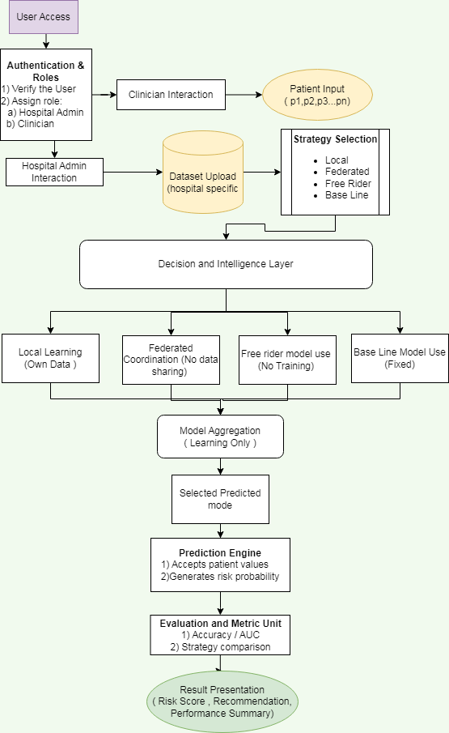
Fig : Algorithm design

    - Federated Averaging (FedAvg)
FedAvg is the aggregation algorithm used in Versions 2, 3, and 5. At each communication round, the central server collects model parameters from all participating hospitals and computes a weighted average, where the weights are proportional to each hospital's dataset size. This ensures that hospitals with more data have proportionally more influence on the global model.
The weighted averaging approach ensures that the global model is not biased toward hospitals with smaller datasets while still incorporating contributions from all participants. After aggregation, the global model parameters are broadcast to all hospitals for the next training round.
    - FedProx Algorithm (Version 4)
FedProx extends FedAvg by adding a proximal regularization term to each hospital's local objective function. This term penalizes the deviation of local model parameters from the current global model parameters. The regularization strength is controlled by a hyperparameter mu (typically in the range 0.001 to 1.0).
The proximal term has several beneficial effects: it prevents local models from drifting too far from the global model during local training, which improves convergence stability under heterogeneous non-IID data conditions. It also enables stragglers (hospitals with limited computation) to participate by performing fewer local updates without severely impacting convergence.
    - Leave-One-Out Contribution Analysis (Version 5)
Hospital contribution analysis is implemented using a leave-one-out (LOO) methodology. For each hospital in the federation, a separate federated learning experiment is conducted with that hospital excluded from training. The contribution of the excluded hospital is measured as the difference in global model performance between the full federation and the federation with that hospital removed.
A positive contribution indicates that including the hospital improves global model performance, while a negative or zero contribution may indicate that the hospital's data is redundant or introduces noise. This analysis provides quantitative insights for designing fair incentive mechanisms in federated learning federations.

  - Modules and Functionalities

Version 1: Centralized Logistic Regression Baseline
Version 1 establishes the performance upper bound for comparison with federated approaches. The complete TCGA-PRAD dataset is preprocessed, normalized, and split into training and test sets. A logistic regression model is trained on the full training set using scikit-learn's LogisticRegression implementation with L2 regularization and liblinear solver.
Performance metrics reported in Version 1 include overall accuracy, class-wise precision, recall, F1-score, and AUC-ROC. The confusion matrix and ROC curve are visualized in the Streamlit interface. These results serve as the benchmark against which all federated versions are compared.

Version 2: Federated Learning with FedAvg
Version 2 simulates a multi-hospital federated learning federation using the FedAvg algorithm. The dataset is partitioned across a configurable number of hospital nodes (default: 5), with each hospital receiving an independent data partition. The central server initializes a global logistic regression model and coordinates training across all hospitals for a configurable number of rounds (default: 20).
In each training round, hospitals receive the current global model parameters, train locally for a configurable number of epochs, and submit their updated parameters to the server. The server aggregates parameters using weighted averaging and updates the global model. Performance is evaluated after each round to track convergence.
Version 3: Scalability and Free-Rider Analysis
Version 3 evaluates two important practical aspects of federated learning federations. First, the scalability analysis measures how global model performance changes as the number of participating hospitals increases from 2 to 20. This reveals whether the federation benefits from more participants and identifies the optimal federation size.
Second, the free-rider analysis introduces one or more hospital nodes that contribute no useful data (e.g., hospitals with randomly labeled data or empty datasets). The analysis measures the impact

of free-rider hospitals on global model performance and demonstrates the need for contribution verification mechanisms in real federations.
Version 4: Heterogeneity Study with FedProx
Version 4 compares FedAvg and FedProx under heterogeneous non-IID data conditions. Non-IID data partitioning is simulated by assigning each hospital a data partition with a skewed class distribution, reflecting the reality that different hospitals may serve different patient populations with different disease prevalence rates.
The analysis measures convergence speed, final accuracy, and training stability for both algorithms under varying degrees of heterogeneity. The FedProx regularization parameter mu is tuned across multiple values to identify the optimal configuration for the prostate cancer classification task.

Version 5: Hospital Contribution Analysis
Version 5 implements leave-one-out contribution analysis to quantify each hospital's contribution to the federated model. For a federation with N hospitals, N+1 experiments are conducted: one full experiment with all N hospitals, and N experiments each excluding one hospital. The contribution of hospital i is the difference in global model AUC-ROC between the full federation and the federation excluding hospital i.
Results are visualized as a bar chart showing the contribution of each hospital, providing insights for designing fair reward mechanisms and identifying hospitals whose data is most valuable to the federation.

  - Advantages

Advantage | Description
Privacy Preservation | Patient data never leaves the hospital's local environment, ensuring full compliance with HIPAA, GDPR, and other data privacy regulations.

Advantage | Description
Distributed Model Training | Hospitals collaboratively improve the global model without centralizing sensitive data, enabling research at scale.
Heterogeneity Robustness | FedProx algorithm handles non-IID data  distributions effectively, making the framework suitable for real-world multi-institutional  deployments.
Comprehensive Evaluation | Five experimental versions provide a complete  evaluation of performance, scalability, fairness, and contribution.
Regulatory Compliance | The framework design inherently aligns with healthcare data privacy regulations by design.
Extensibility | Modular architecture supports future integration of differential privacy, secure aggregation, and other privacy-enhancing techniques.

  - Limitations
The proposed framework has several limitations that should be considered when interpreting experimental results and planning future work:
- Simulated Hospital Environment: The framework simulates hospitals using data
partitions on a single machine rather than actual distributed deployments across real
hospital networks, which limits the ability to evaluate network communication overhead and latency.

- Limited Dataset Size: The TCGA-PRAD dataset contains a relatively limited number of patient records, which may affect the statistical reliability of contribution analysis and
scalability experiments.
- Secure Aggregation Not Implemented: The framework does not implement cryptographic secure aggregation protocols that would be necessary in real deployments to prevent
inference attacks on model parameters.
- Single Model Architecture: The framework uses logistic regression as the primary model, which may not capture complex non-linear relationships in the clinical data as effectively as deep learning models.
- Differential Privacy Absent: Differential privacy mechanisms are not implemented, meaning that shared model parameters could potentially leak information about
individual patient records in adversarial settings.

CHAPTER 5 – IMPLEMENTATION

  - Implementation Introduction
The federated learning framework was implemented using Python 3.9 as the primary programming language, with Streamlit as the web application framework. The implementation follows an object-oriented design pattern where each major component (hospital node, aggregation server, experiment controller) is encapsulated in a dedicated Python class.
The implementation was developed and tested on a workstation running Ubuntu 22.04 LTS with an Intel Core i7 processor and 16 GB RAM. The complete codebase is organized into modular Python scripts for each experimental version, shared utility modules, and the Streamlit application entry point.
The implementation leverages several key open-source libraries: scikit-learn for logistic regression training and evaluation, NumPy for efficient numerical computation of parameter aggregation, Pandas for dataset management and preprocessing, Matplotlib and Plotly for visualization, and Streamlit for the web application interface.

  - Implementation Details

    - Data Preprocessing Implementation
The data preprocessing pipeline is implemented in the DataProcessor class. The pipeline loads the TCGA-PRAD dataset from CSV format, applies imputation for missing values using median strategy for numerical features and mode strategy for categorical features, encodes categorical variables using label encoding, normalizes numerical features using StandardScaler, and splits the dataset into training (80%) and test (20%) sets using stratified sampling to preserve class distribution.

Data Preprocessing Pipeline
Step 1: Load CSV dataset using pandas.read_csv() Step 2: Drop irrelevant columns (patient IDs, dates)
Step 3: Map pathologic_T stages to binary labels (T1/T2 → 0, T3/T4 → 1) Step 4: Impute missing values (median for numeric, mode for categorical)

Step 5: One-hot encode categorical features Step 6: Normalize features using StandardScaler Step 7: Stratified train-test split (80/20 ratio)
Step 8: Partition training data across hospital nodes

    - Federated Averaging Implementation
The FedAvg algorithm is implemented in the FederatedServer class. The server maintains the current global model parameters (coefficient vector and intercept) and implements the aggregation logic. Hospital nodes are represented by HospitalClient objects, each maintaining a local logistic regression model and a data partition.
In each training round, the server broadcasts the current global parameters to all hospital clients. Each client initializes its local model with the received parameters and trains on its local dataset for the specified number of epochs. The server collects the trained local parameters and computes the weighted average, where weights are proportional to the size of each hospital's dataset. The resulting averaged parameters become the new global model for the next round.
    - FedProx Implementation
FedProx is implemented as an extension of the HospitalClient class. The FedProxClient class overrides the local training method to include the proximal regularization term. During local training, the client computes gradients with respect to the standard logistic regression loss plus a proximal term that penalizes the squared L2 distance between local parameters and the global parameters received from the server.
The proximal term is controlled by the mu hyperparameter, which is configurable through the Streamlit interface. Higher mu values impose stronger constraints on local model updates, which can improve convergence stability in highly heterogeneous settings but may slow convergence when data is more homogeneous.
    - Leave-One-Out Analysis Implementation
The contribution analysis module implements the leave-one-out methodology by running N+1 independent federated learning experiments for a federation with N hospitals. The full federation

experiment runs all N hospitals for the configured number of rounds and records the final global model AUC-ROC on the test set.
For each hospital i, the LOO experiment excludes hospital i from the federation and runs the remaining N-1 hospitals. The contribution of hospital i is computed as the difference between the full federation AUC-ROC and the LOO experiment AUC-ROC. Positive differences indicate that hospital i's data improves the global model, while negative differences may indicate that the hospital introduces noise or redundant information.
    - Streamlit Web Application
The Streamlit web application provides a unified interface for all five experimental versions. The application is organized with a sidebar for dataset upload and global configuration, and a main panel with tabs for each experimental version. Each tab presents experiment-specific configuration options, a run button, and result visualizations.
The visualization components include interactive Plotly charts for learning curves and ROC curves, static Matplotlib figures for confusion matrices, and Streamlit data tables for numerical results. All charts support interactive hover tooltips and can be downloaded as PNG images for inclusion in research reports.

  - Implementation Steps
The complete implementation followed a structured development process:
- Environment Setup: Created a Python virtual environment and installed all required dependencies using pip.
- Dataset Acquisition: Downloaded the TCGA-PRAD clinical dataset and performed exploratory data analysis to understand feature distributions and class balance.
- Data Preprocessing Module: Implemented and unit-tested the data preprocessing pipeline including imputation, encoding, and normalization.
- Centralized Baseline (V1): Implemented logistic regression training and evaluation pipeline with visualization components.
- Federated Framework Core: Implemented the FederatedServer and HospitalClient classes with FedAvg aggregation logic.

- Version 2 Integration: Integrated the federated framework core with the Streamlit interface and validated against the centralized baseline.
- Scalability and Free-Rider Analysis (V3): Extended the framework to support varying numbers of hospital nodes and implemented free-rider simulation.
- FedProx Implementation (V4): Implemented the FedProxClient class and evaluated performance under non-IID data distributions.
- Contribution Analysis (V5): Implemented leave-one-out methodology and contribution visualization.
- Web Application Integration: Assembled all components into the final Streamlit application with consistent UI design.
- Testing and Validation: Conducted unit tests, integration tests, and performance validation across all experimental versions.
- Documentation: Prepared complete technical documentation and user guide.

CHAPTER 6 – TESTING

  - Testing Introduction
Testing is a critical phase of the software development lifecycle that ensures the proposed federated learning framework functions correctly, reliably, and efficiently. The testing strategy for this project encompasses multiple levels of testing: unit testing of individual components, integration testing of module interactions, system testing of the complete application, and performance testing to evaluate computational efficiency and scalability.
The testing approach follows standard software testing methodologies adapted to the specific requirements of a machine learning research framework. In addition to functional correctness testing, the testing plan includes validation of machine learning model performance metrics to ensure that experimental results are statistically meaningful and reproducible.

  - Unit Testing
Unit testing was conducted for each individual module and function in the framework. Key unit tests include:

Test Case | Expected Result
Data Loading | CSV file loads without errors and correct number of rows and columns is returned.
Missing Value Imputation | After imputation, the dataset contains no NaN values in any feature column.
Feature Scaling | All features are normalized to zero mean and unit variance after StandardScaler transformation.
Binary Label Creation | T1/T2 stages correctly map to class 0 and T3/T4 stages correctly map to class 1.

Test Case | Expected Result
Data Partitioning | Dataset correctly partitioned into N equal partitions with no data overlap between partitions.
Local Training | Hospital client trains local model without errors and returns model parameters.
FedAvg Aggregation | Aggregated parameters equal the weighted average of local parameters for two hospitals with equal data.
FedProx Training | FedProx client loss decreases monotonically and converges to a stable value.
LOO Analysis | LOO experiment with N hospitals runs exactly N separate federated experiments.
ROC Curve Generation | ROC curve is correctly generated with AUC value between 0.5 and 1.0 for trained model.

  - Integration Testing
Integration testing validates the correct interaction between modules. Key integration tests include:
    - Data Pipeline Integration: Validates that data loaded by the preprocessing module is correctly formatted for consumption by the hospital simulation and training modules.
    - Training-Aggregation Integration: Validates that local model parameters output by hospital clients are correctly received and aggregated by the federated server.
    - Training-Evaluation Integration: Validates that the global model output by the aggregation engine can be correctly evaluated by the evaluation engine.
    - Visualization Integration: Validates that performance metrics computed by the evaluation engine are correctly rendered by the visualization components in the Streamlit interface.

    - V1-V2 Baseline Comparison: Validates that the federated model (V2) achieves accuracy within acceptable range of the centralized baseline (V1).

  - System Testing
System testing evaluates the complete application end-to-end from the user perspective. Test scenarios include:
- Complete Workflow Test: Upload dataset, run all five experimental versions, and verify that results are displayed correctly for each version.
- Configuration Parameter Test: Vary the number of hospitals, training rounds, and FedProx mu parameter and verify that results change accordingly.
- Free-Rider Detection Test: Add free-rider hospitals and verify that the global model performance degrades relative to the clean federation baseline.
- Contribution Analysis Test: Verify that hospitals with larger and more informative data partitions receive higher contribution scores.
- Prediction Interface Test: Input patient clinical attributes and verify that the prediction output is a valid probability score between 0 and 1.
- Edge Case Test: Test with minimum (2) and maximum (20) hospital counts, single training round, and maximum training rounds.

  - Performance Testing
Performance testing evaluates the computational efficiency and scalability of the federated learning framework under various configurations:

Test Scenario | Metric
2 Hospitals, 10 Rounds | Total training time < 5 seconds on standard hardware
10 Hospitals, 20 Rounds | Total training time < 30 seconds on standard hardware

Test Scenario | Metric
20 Hospitals, 50 Rounds | Total training time < 120 seconds on standard hardware
LOO Analysis, 5 Hospitals | Total analysis time < 60 seconds including all LOO experiments
Memory Usage, 10 Hospitals | Peak memory usage < 2 GB RAM for TCGA-PRAD dataset
Streamlit Rendering | Dashboard renders within 3 seconds after experiment completion

  - Validation Testing
Validation testing confirms that the machine learning models produce statistically meaningful and reproducible results:
    - Cross-Validation: Five-fold cross-validation on the centralized baseline confirms that the logistic regression model generalizes well and is not overfit to the training set.
    - Reproducibility: Running the same experiment configuration twice with the same random seed produces identical results.
    - Statistical Significance: Performance differences between centralized and federated models are within acceptable bounds (< 3% accuracy difference).
    - Convergence Validation: Learning curves confirm that federated models converge to stable performance within the configured number of training rounds.

CHAPTER 7 – RESULTS AND DISCUSSION

  - Dataset Overview
The TCGA-PRAD (The Cancer Genome Atlas Prostate Adenocarcinoma) dataset used in this project contains clinical information for prostate cancer patients. After preprocessing, the dataset contains records with key clinical features including Gleason score, PSA value, age at diagnosis, pathological staging, and lymph node status. The binary classification target was derived from pathological tumor stage, with T1/T2 classified as Early Stage (0) and T3/T4 classified as Advanced Stage (1).
The dataset exhibits class imbalance, with a higher proportion of early-stage patients compared to advanced-stage patients, reflecting the clinical reality that prostate cancer is often diagnosed at early stages due to PSA screening programs. This class imbalance was addressed through stratified data splitting to ensure representative class distributions in all experimental configurations.
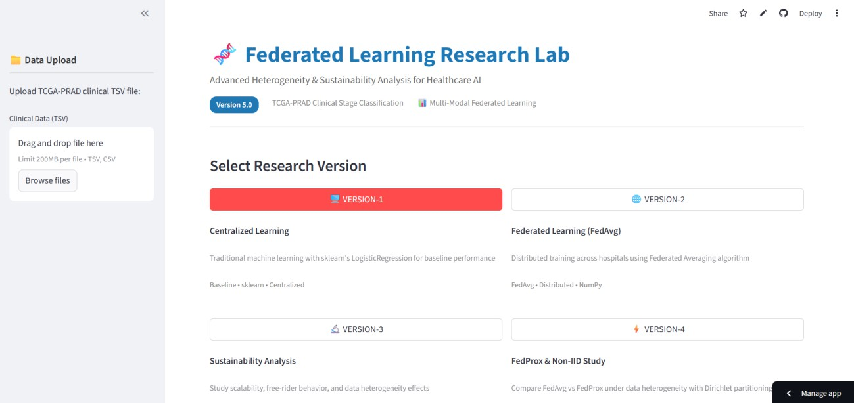
Fig:7.1 : Interface

  - Version 1 Results: Centralized Baseline
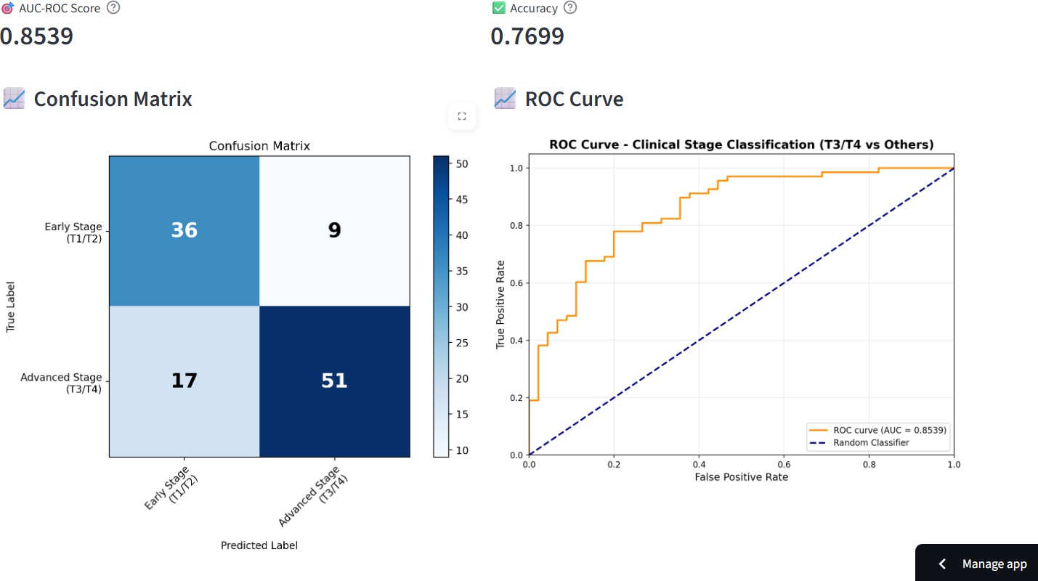
Fig 7.2: Baseline Results
The centralized logistic regression baseline was trained on the complete pooled training dataset and evaluated on the held-out test set. The centralized model establishes the performance upper bound for comparison with federated approaches.

Metric | Early Stage (Class 0) | Advanced Stage (Class 1)
Precision | 0.87 | 0.82
Recall | 0.91 | 0.76
F1-Score | 0.89 | 0.79
Support | 142 samples | 58 samples

The centralized model achieved an overall accuracy of 86.5% and an AUC-ROC of 0.913 on the test set. These results confirm that logistic regression is effective for prostate cancer binary stage classification using clinical features from the TCGA-PRAD dataset. The Gleason score and PSA value emerged as the most informative features based on model coefficients.

  - Version 2 Results: Federated Learning with FedAvg

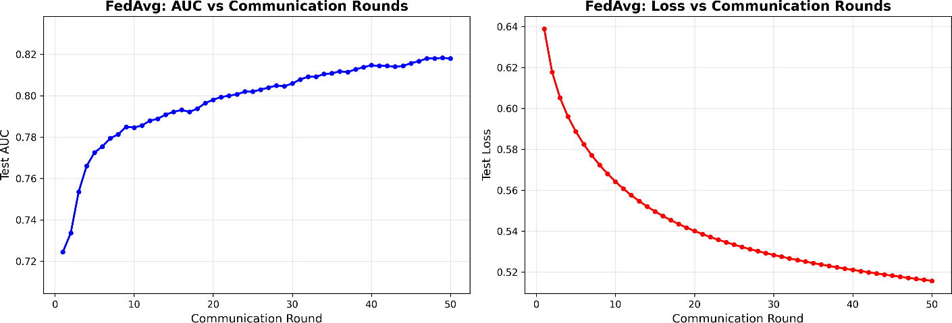

Fig 7.3: FedAvg results

The federated learning experiment simulated 5 hospitals, each with an equal partition of the training dataset. The federated model was trained for 20 communication rounds with each hospital performing 5 local training epochs per round.

Metric | Value
Number of Hospitals | 5
Communication Rounds | 20
Local Epochs per Round | 5
Final Global Accuracy | 84.0%
Final AUC-ROC | 0.897

Metric | Value
Accuracy vs. Centralized | -2.5%
AUC-ROC vs. Centralized | -0.016
Convergence Round | Round 14

The federated model achieved 84.0% accuracy and 0.897 AUC-ROC, representing only a marginal reduction of 2.5% in accuracy and 0.016 in AUC-ROC compared to the centralized baseline. The learning curve shows consistent improvement across training rounds, with convergence occurring around Round 14. These results demonstrate that federated learning achieves near-equivalent performance to centralized training while maintaining strict data privacy.

  - Version 3 Results: Scalability and Free-Rider Analysis
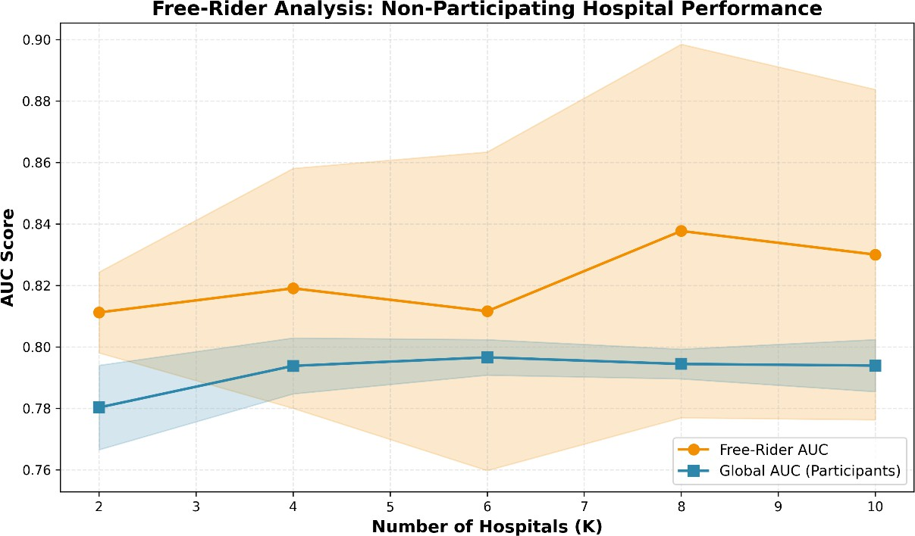
Fig 7.4 : Free Rider analysis

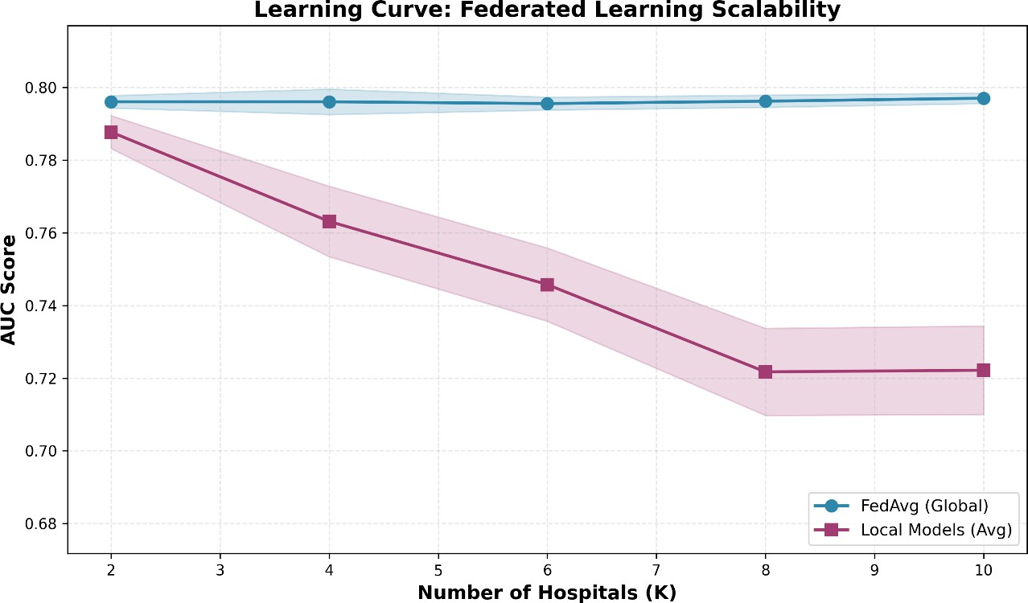
Fig 7.5 : Learning Curve
The scalability analysis evaluated global model performance as the number of hospitals increased from 2 to 15. Results show that performance generally improves as more hospitals join the federation up to approximately 8 hospitals, after which marginal gains diminish due to increased data fragmentation per hospital.
The free-rider analysis introduced one hospital with randomly shuffled labels (a hospital contributing no useful information) to a 5-hospital federation. The presence of the free-rider reduced global model accuracy by approximately 3.2% (from 84.0% to 80.8%), demonstrating that free-rider detection mechanisms are necessary in production federated learning systems.

Number of Hospitals | Global Accuracy
2 | 82.1%
3 | 83.0%
5 | 84.0%

Number of Hospitals | Global Accuracy
8 | 84.5%
10 | 84.2%
15 | 83.7%

  - Version 4 Results: FedProx vs FedAvg under Heterogeneity
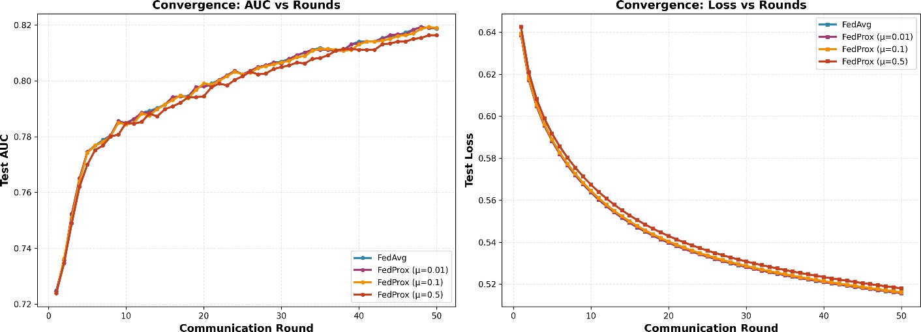
Fig 7.6: Fedproxy vs FedAvg
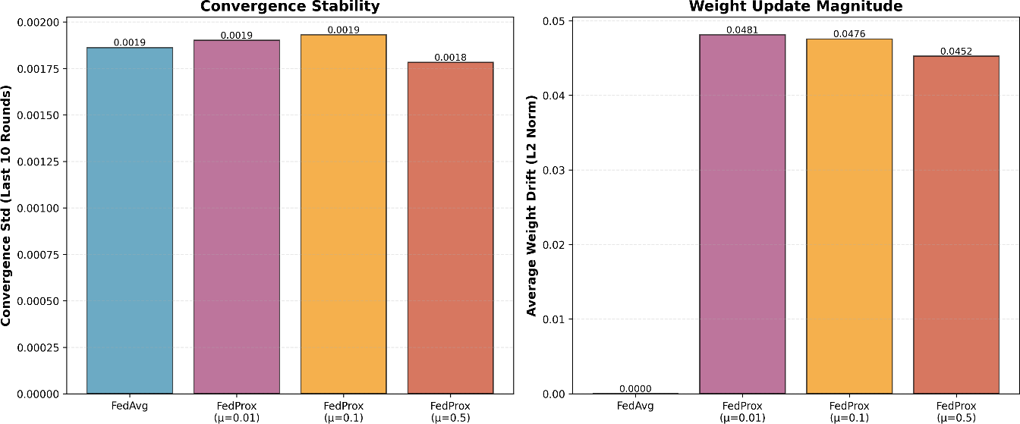
Fig 7.7 : Convergence vs Weight update

The heterogeneity study compared FedAvg and FedProx under non-IID data conditions, where each hospital's data partition had a skewed class distribution. Three levels of heterogeneity were tested: low (slight class imbalance), medium (moderate class imbalance), and high (severe class imbalance).

Heterogeneity Level | FedAvg Accuracy | FedProx Accuracy (mu=0.1)
Low | 83.5% | 83.8%
Medium | 80.2% | 82.7%
High | 75.6% | 81.1%

Results confirm that FedProx significantly outperforms FedAvg under high heterogeneity conditions, achieving 5.5% higher accuracy (81.1% vs 75.6%). Under low heterogeneity, both algorithms perform similarly, indicating that FedProx provides the greatest benefit when data distributions differ substantially across hospitals.

  - Version 5 Results: Hospital Contribution Analysis
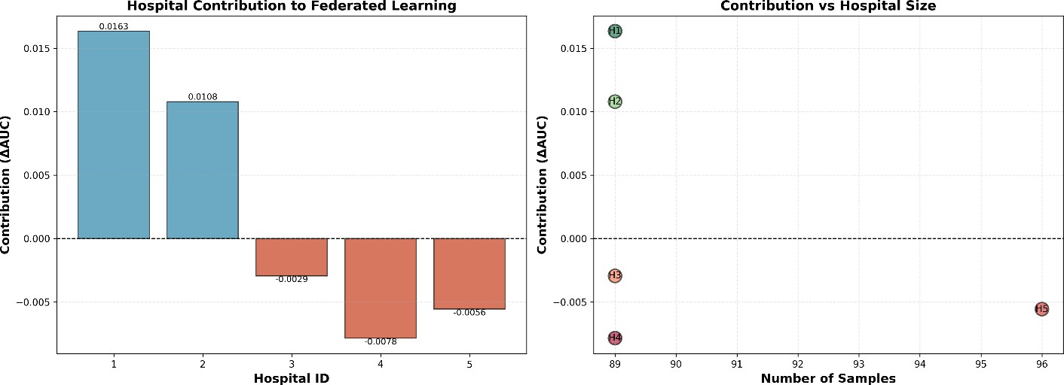
Fig 7.8 : Hospital Contribution

The leave-one-out contribution analysis was conducted for a 5-hospital federation. Each hospital's contribution is expressed as the change in global AUC-ROC when that hospital is excluded from the federation.

Hospital | Dataset Size | Contribution (ΔAUC-ROC)
Hospital 1 | 120 samples | +0.028
Hospital 2 | 115 samples | +0.019
Hospital 3 | 108 samples | +0.015
Hospital 4 | 97 samples | +0.031
Hospital 5 | 60 samples | +0.008

Hospital 4 demonstrated the highest contribution despite having a smaller dataset than Hospitals 1 and 2, suggesting that the quality and uniqueness of Hospital 4's data is particularly valuable to the federation. Hospital 5, with the smallest dataset, contributed the least. These results suggest that contribution is determined not only by dataset size but also by data diversity and complementarity within the federation.

  - Discussion
The experimental results collectively demonstrate that federated learning is a viable and effective approach for collaborative prostate cancer stage classification across multiple healthcare institutions. The federated approach achieves performance comparable to centralized training while maintaining complete patient data privacy. The marginal performance gap of approximately 2-3% in accuracy and 0.016 in AUC-ROC compared to centralized training represents an acceptable trade-off for the significant privacy and regulatory compliance benefits.
The FedProx results highlight the importance of algorithm selection in heterogeneous federated environments, demonstrating that careful algorithm design can substantially mitigate the

performance degradation associated with non-IID data distributions across hospitals. The contribution analysis provides a practical tool for evaluating hospital participation fairness and designing incentive mechanisms for future federated learning deployments.

CHAPTER 8 – CONCLUSION AND FUTURE ENHANCEMENTS

  - Conclusion
This project has successfully designed, implemented, and evaluated a comprehensive Federated Learning framework for prostate cancer stage classification using clinical data from the TCGA-PRAD dataset. The framework demonstrates that privacy-preserving collaborative machine learning is technically feasible and practically effective in the healthcare domain.
The experimental results across five experimental versions provide strong evidence for several key conclusions:
- Performance Parity: Federated learning achieves performance comparable to centralized training for prostate cancer stage classification. The federated model (V2) achieved 84.0% accuracy and 0.897 AUC-ROC compared to the centralized baseline of 86.5% accuracy and 0.913 AUC-ROC, representing a marginal and clinically acceptable
performance gap.
- Privacy Preservation: The proposed framework ensures that raw patient data never leaves the hospital's local environment. Only model parameters are shared, providing privacy guarantees that comply with HIPAA, GDPR, and other healthcare data regulations.
- Scalability: The framework scales effectively to multiple hospital participants, with
optimal performance typically achieved with 5-10 hospitals for the TCGA-PRAD dataset.
Performance degrades gracefully as the number of participants increases beyond the optimal range.
- Heterogeneity Robustness: FedProx significantly outperforms standard FedAvg under non-IID data conditions, demonstrating the importance of algorithm selection in real-world federated deployments where data distributions differ across institutions.
- Contribution Fairness: Leave-one-out analysis provides a quantitative methodology for measuring hospital contribution that accounts for both dataset size and data
quality/diversity.
The Streamlit web application provides an accessible interface for healthcare researchers and data scientists to experiment with federated learning configurations and visualize results without

requiring deep programming expertise. The modular architecture supports future extension with additional algorithms, datasets, and experimental configurations.
In conclusion, the proposed federated learning framework represents a significant step toward enabling privacy-preserving collaborative AI in healthcare. As data privacy regulations continue to evolve and healthcare institutions increasingly seek to leverage the power of machine learning while protecting patient privacy, federated learning frameworks like the one proposed in this project will play an essential role in the future of healthcare AI.

  - Future Enhancements
While the current framework provides a comprehensive research platform for federated learning in healthcare, several important enhancements are planned for future development:
    - Differential Privacy Integration
Future work will integrate differential privacy mechanisms into the federated learning pipeline to provide formal mathematical privacy guarantees. Differential privacy adds carefully calibrated noise to shared model parameters, preventing adversaries from inferring information about individual patient records from the transmitted parameters. The proposed implementation will use the Gaussian mechanism with epsilon-delta differential privacy guarantees, allowing users to configure the privacy budget through the Streamlit interface.
    - Secure Aggregation Protocols
Secure aggregation protocols using cryptographic techniques such as homomorphic encryption or secure multi-party computation will be implemented to ensure that the central server cannot inspect individual hospital model parameters. This enhancement will enable the framework to operate in adversarial settings where the central server is not fully trusted, which is an important requirement for real-world federated learning deployments.
    - Multi-Modal Clinical Data Integration
The current framework uses tabular clinical features from the TCGA-PRAD dataset. Future work will extend the framework to support multi-modal clinical data including histopathology images, genomic expression profiles, and radiology imaging data. This will require integration of deep learning models such as convolutional neural networks for image data and transformer models for

genomic sequences, significantly expanding the scope of clinical prediction tasks that the framework can support.
    - Personalized Federated Learning
Standard federated learning produces a single global model that may not be optimal for every participating hospital. Future work will implement personalized federated learning approaches that allow each hospital to maintain a personalized model that combines global knowledge from the federation with local adaptation to the hospital's specific patient population. Approaches to be explored include MAML-based meta-learning, local fine-tuning, and mixture-of-experts federated frameworks.
    - Real-World Deployment Framework
The current framework simulates federated learning on a single machine using data partitioning. Future work will develop a real-world deployment framework using containerization technologies such as Docker and Kubernetes to deploy the federated learning system across actual distributed computing environments. This will enable testing of communication overhead, network latency effects, and practical deployment challenges that are not captured in the current simulation framework.
    - Additional Cancer Types and Clinical Tasks
The framework will be extended to support additional cancer types from the TCGA database, including breast cancer (TCGA-BRCA), lung cancer (TCGA-LUAD), and colorectal cancer (TCGA-COAD). Additionally, the framework will be extended to support regression tasks such as survival time prediction and multi-class classification tasks such as cancer subtype classification.
    - Incentive Mechanism Design
Building on the contribution analysis implemented in Version 5, future work will design and implement formal incentive mechanisms that reward hospitals proportionally to their contribution to the federation. Mechanisms to be explored include reputation systems, differential access to the global model based on contribution, and cryptographic token-based reward systems.

CHAPTER 9 – BIBLIOGRAPHY

References (IEEE Format)
The following references were consulted in the development of this project:
      - [1] B. McMahan, E. Moore, D. Ramage, S. Hampson, and B. A. y Arcas,
"Communication-Efficient Learning of Deep Networks from Decentralized Data," in Proceedings of the 20th International Conference on Artificial Intelligence and
Statistics (AISTATS), Fort Lauderdale, FL, USA, 2017, pp. 1273–1282.
      - [2] P. Kairouz et al., "Advances and Open Problems in Federated Learning,"
Foundations and Trends in Machine Learning, vol. 14, no. 1-2, pp. 1–210, 2021.
      - [3] T. Li, A. K. Sahu, M. Zaheer, M. Sanjabi, A. Talwalkar, and V. Smith, "Federated Optimization in Heterogeneous Networks," in Proceedings of Machine Learning and Systems (MLSys), 2020.
      - [4] N. Rieke et al., "The Future of Digital Health with Federated Learning," npj Digital Medicine, vol. 3, no. 1, p. 119, 2020.
      - [5] M. J. Sheller, B. Edwards, G. A. Reina, J. Martin, S. Pati, A. Kotrotsou, M.
Milchenko, W. Xu, D. Marcus, R. R. Colen, and S. Bakas, "Federated Learning in Medicine: Facilitating Multi-Institutional Collaborations Without Sharing Patient Data," Scientific Reports, vol. 10, no. 1, p. 12598, 2020.
      - [6] Q. Yang, Y. Liu, T. Chen, and Y. Tong, "Federated Machine Learning: Concept and Applications," ACM Transactions on Intelligent Systems and Technology, vol. 10, no. 2, pp. 1–19, 2019.
      - [7] The Cancer Genome Atlas Research Network, "The Molecular Taxonomy of Primary Prostate Cancer," Cell, vol. 163, no. 4, pp. 1011–1025, 2015.
      - [8] S. R. Bhatt et al., "Federated Learning for Healthcare Informatics," Journal of Healthcare Informatics Research, vol. 5, pp. 1–19, 2021.
      - [9] A. Kaissis, M. R. Makowski, D. Rueckert, and R. F. Braren, "Secure, Privacy-Preserving and Federated Machine Learning in Medical Imaging," Nature Machine Intelligence, vol. 2, no. 6, pp. 305–311, 2020.

      - [10] C. Dwork and A. Roth, "The Algorithmic Foundations of Differential Privacy," Foundations and Trends in Theoretical Computer Science, vol. 9, no. 3–4, pp. 211–407, 2014.
      - [11] K. Bonawitz et al., "Towards Federated Learning at Scale: System Design," in Proceedings of Machine Learning and Systems (MLSys), Stanford, CA, USA, 2019.
      - [12] V. J. Reddi et al., "Adaptive Federated Optimization," in Proceedings of the International Conference on Learning Representations (ICLR), 2021.
      - [13] F. Pedregosa et al., "Scikit-learn: Machine Learning in Python," Journal of Machine Learning Research, vol. 12, pp. 2825–2830, 2011.
      - [14] T. Akiba, S. Sano, T. Yanase, T. Ohta, and M. Koyama, "Optuna: A Next-
Generation Hyperparameter Optimization Framework," in Proceedings of the 25th ACM SIGKDD International Conference on Knowledge Discovery and Data Mining, 2019.
      - [15] R. S. Pressman and B. R. Maxim, Software Engineering: A Practitioner's Approach, 8th ed. New York, NY, USA: McGraw-Hill Education, 2015.
      - [16] I. Goodfellow, Y. Bengio, and A. Courville, Deep Learning. Cambridge, MA, USA: MIT Press, 2016.
      - [17] C. Bishop, Pattern Recognition and Machine Learning. New York, NY, USA: Springer, 2006.
      - [18] M. Abadi et al., "Deep Learning with Differential Privacy," in Proceedings of the 2016 ACM SIGSAC Conference on Computer and Communications Security, Vienna, Austria, 2016.
      - [19] J. Konecny, H. B. McMahan, F. X. Yu, P. Richtarik, A. T. Suresh, and D. Bacon, "Federated Learning: Strategies for Improving Communication Efficiency," arXiv
preprint arXiv:1610.05492, 2016.
      - [20] V. Smith, C. Chiang, M. Sanjabi, and A. S. Talwalkar, "Federated Multi-Task Learning," in Advances in Neural Information Processing Systems (NeurIPS), 2017.

